**Database Project-Lab10**

Submitted by:

Naveenkumar Venkataswamy

Norah Alshahrani

Irfan Yaqoob

Numan Zafar

GitHub link: <https://github.com/yaqoobirfan/DatabaseProjectDjango>

Q1:-Creating the demo_django project

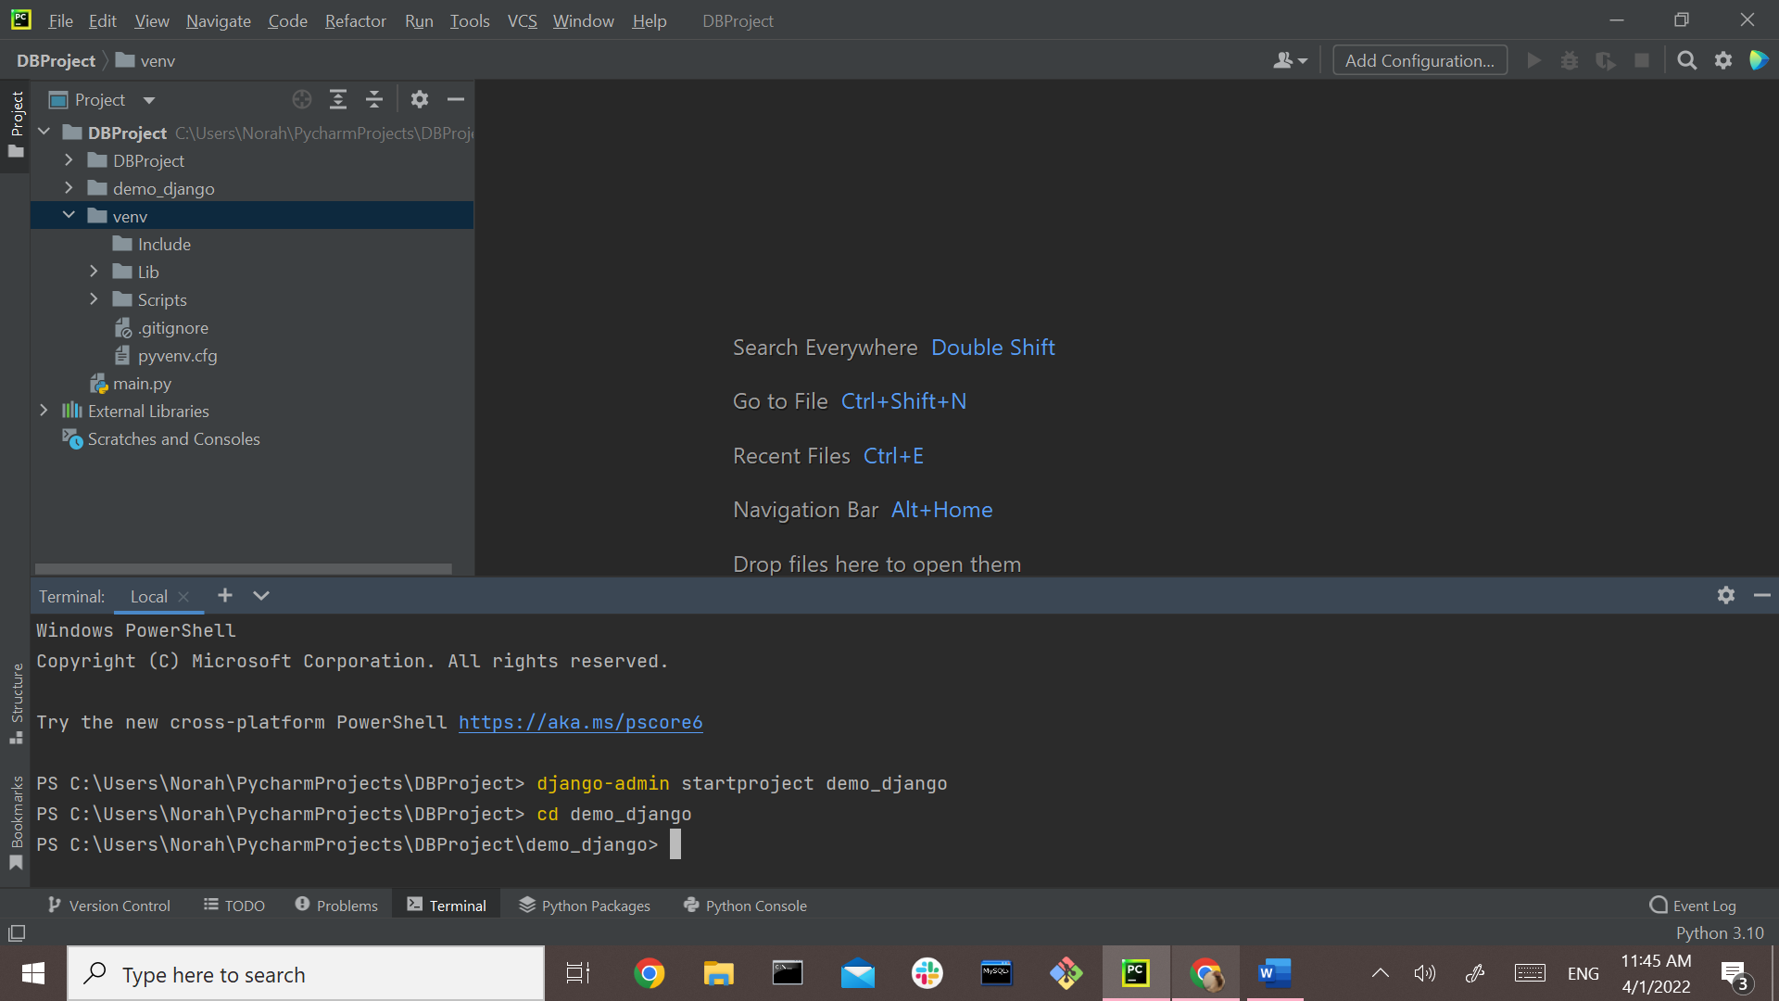

Q2: Editing settings.py file to setup a MySQL connection

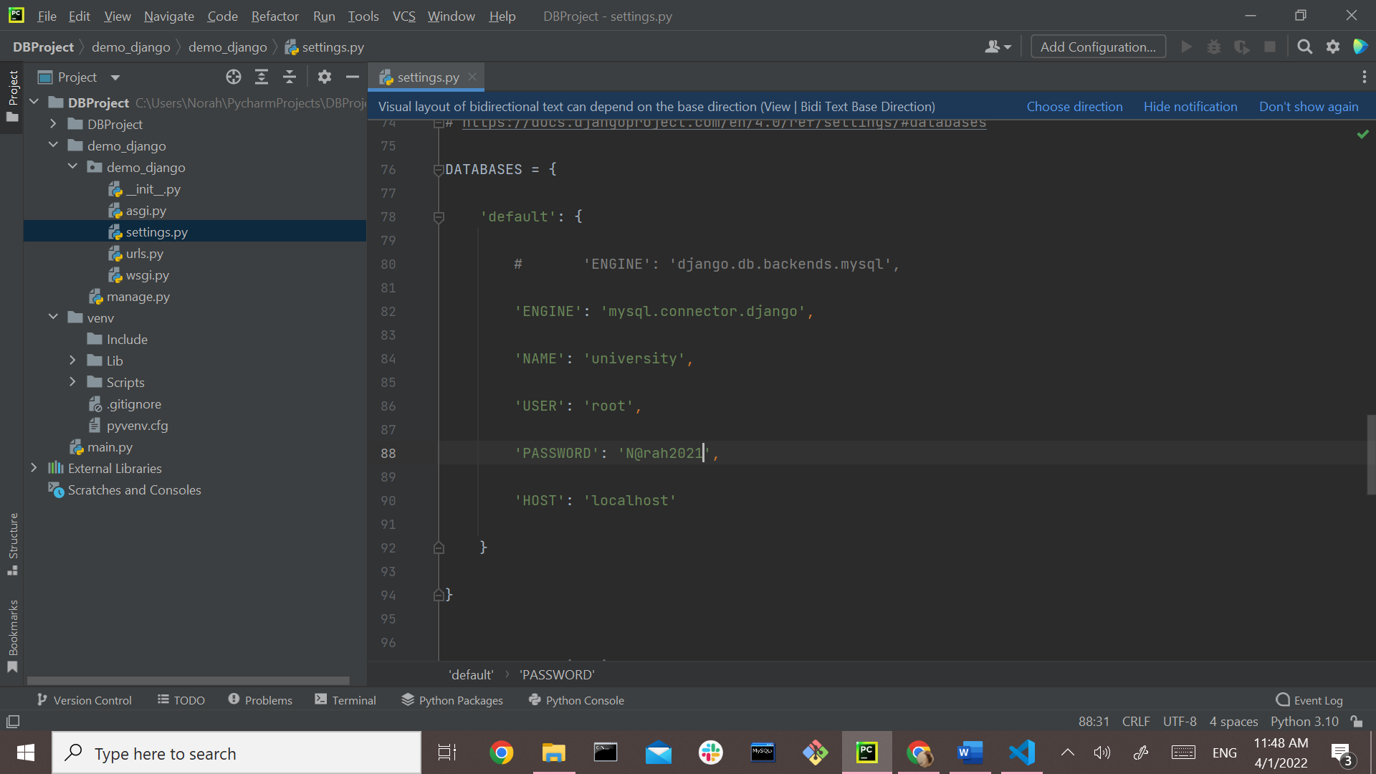

Q3: Create a view in demo_django/views.py set up a URL for it in demo_django/urls.py

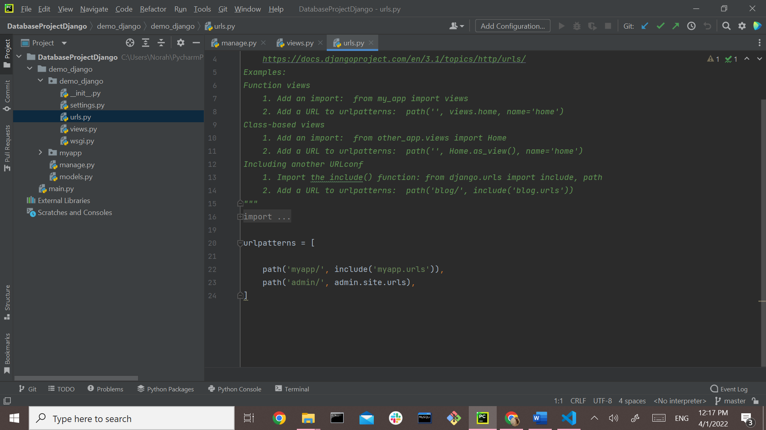

Q4: Create myapp/views.py and Configure myapp/urls.py  and demo_django/urls.py

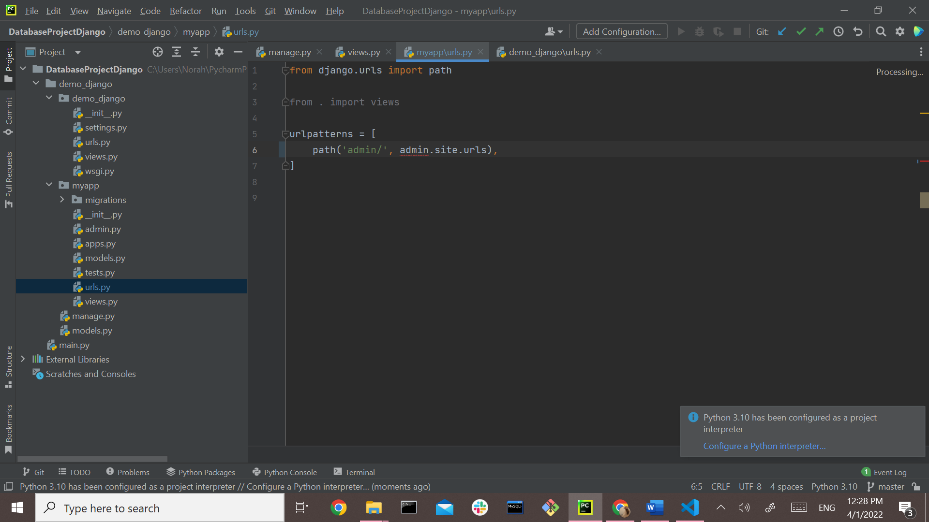

Q5: python manage.py inspectdb > models.py ;Edit models.py to keep only Instructor, Student, and Dept.

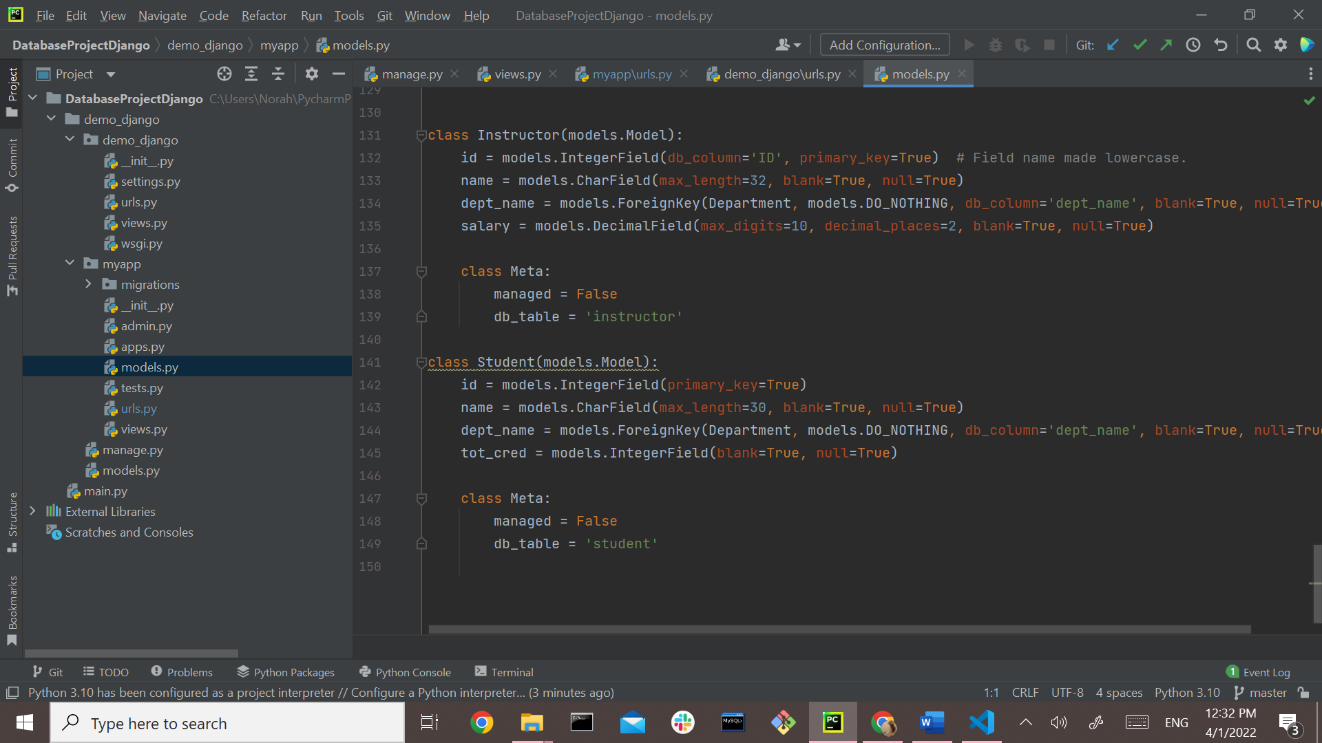

Q6: apps.py in settings.py

